 

PROJECT WORK

PROJECT TITLE: COMPREHENSIVE DIGITAL

MARKETING REPORT FOR MAHINDRA&

MAHINDRA

LTD

NAME:N.HARIKA

TEAM ID:LTVIP2025TMID21886

COMPREHENSIVE DIGITAL MARKETING

REPORT FOR MAHINDRA& MAHINDRA

LTD

 

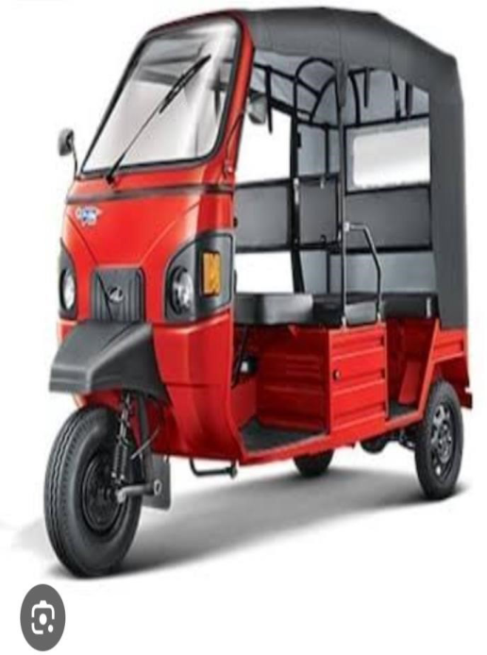

 



BRAND STUDY:

Brand Study: Mahindra & Mahindra Ltd.

1.Overview of Mahindra & Mahindra

Mahindra & Mahindra Ltd. (M&M) is an Indian multinational company headquartered in Mumbai, Maharashtra. It is one of the largest automobile manufacturers in India and a part of the Mahindra Group, a $20+ billion conglomerate operating in over 100   
countries.

2.History & Evolution

1945: Founded as Mahindra & Mohammed, initially focusing on steel trading.

 

 

1947: Started assembling Willys Jeeps in India, marking its entry into the automobile

sector.

1950s–70s: Expanded into tractors, utility vehicles, and industrial equipment.

1990s–2000s: Diversified into IT (Tech Mahindra), finance, and renewable energy.

2010s–Present: Expanded globally with acquisitions (SsangYong, Pininfarina) and

investments in electric vehicles (EVs).

3.Brand Identity & Values

Tagline: “Rise” – symbolizes innovation, sustainability, and global aspirations.

Core Values: Innovation, sustainability, trust, customer-centricity.

Brand Positioning: A leader in SUVs, farm equipment, and electric mobility, catering to

both rural and urban markets.

4.Product Portfolio

A. Automobiles

SUVs: Scorpio, Thar, XUV700, Bolero, XUV300.

Electric Vehicles: XUV400 EV, Treo (electric 3wheeler).

 

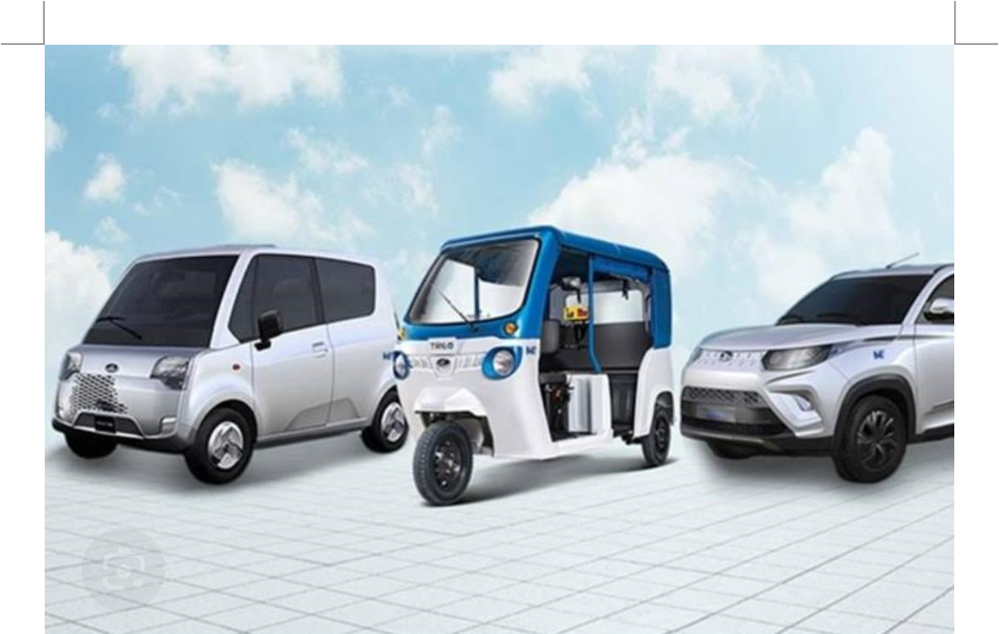

Commercial Vehicles: Jeeto, Supro, Blazo trucks.

 

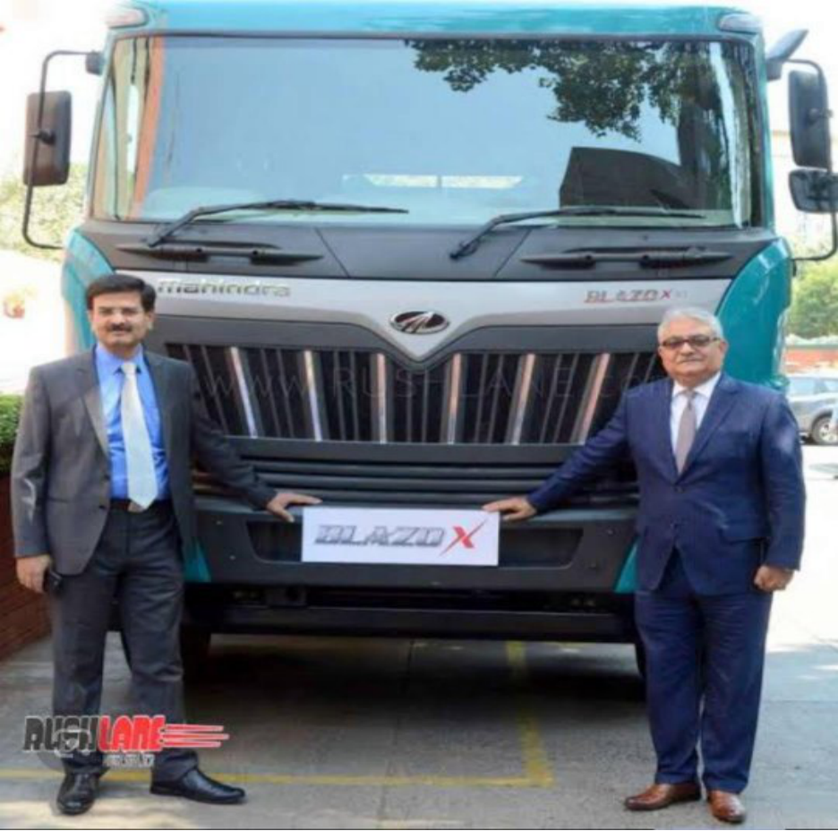





B. Farm Equipment

Tractors: Mahindra Tractors is the world’s largest tractor manufacturer by volume.

Implements: Advanced agricultural machiner

 



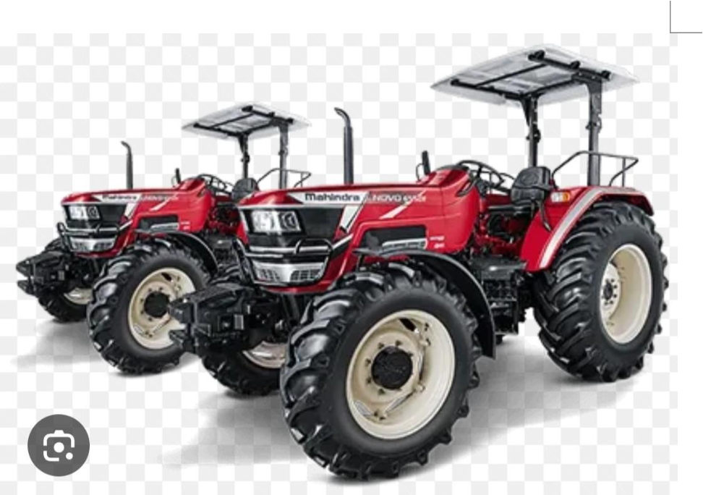

Mahindra & Mahindra is a diversified Indian multinational company known for its

automobiles, tractors, and various other business verticals.



BUYERS/AUDIENCES

PERSONA:

1. Automotive Segment (SUVs & Pickup Trucks)

Persona Name: Rajesh, the Adventure Seeker

 

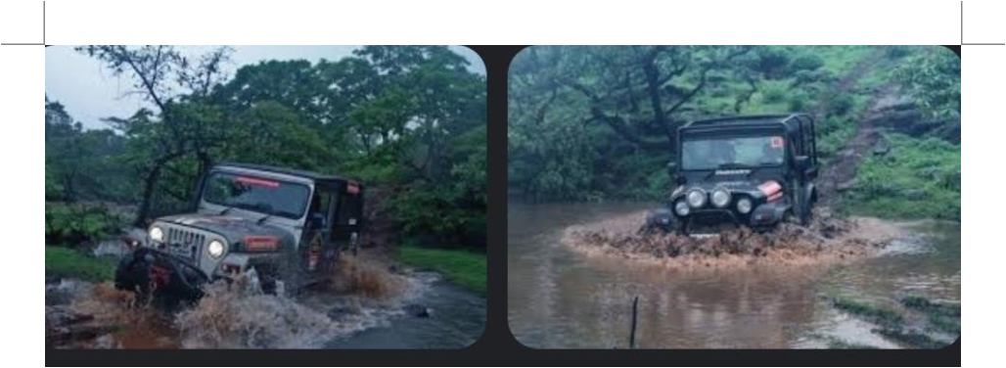

Age: 28-45

Occupation: Mid-level professional or business owner

Income Level: Middle to upper-middle class

Location: Urban and semi-urban areas

Interests: Road trips, off-roading, adventure sports

Pain Points: Wants a rugged, reliable, and stylish SUV with great mileage and

affordability

Buying Motivation: Safety, durability, strong road presence, after-sales service

Preferred Vehicles: Mahindra Thar, Scorpio, XUV700, Bolero



 

 

2. Commercial Vehicle Buyers

Persona Name: Suresh, the Small Business Owner

Age: 30-50

Occupation: Small business owner, transporter, or farmer

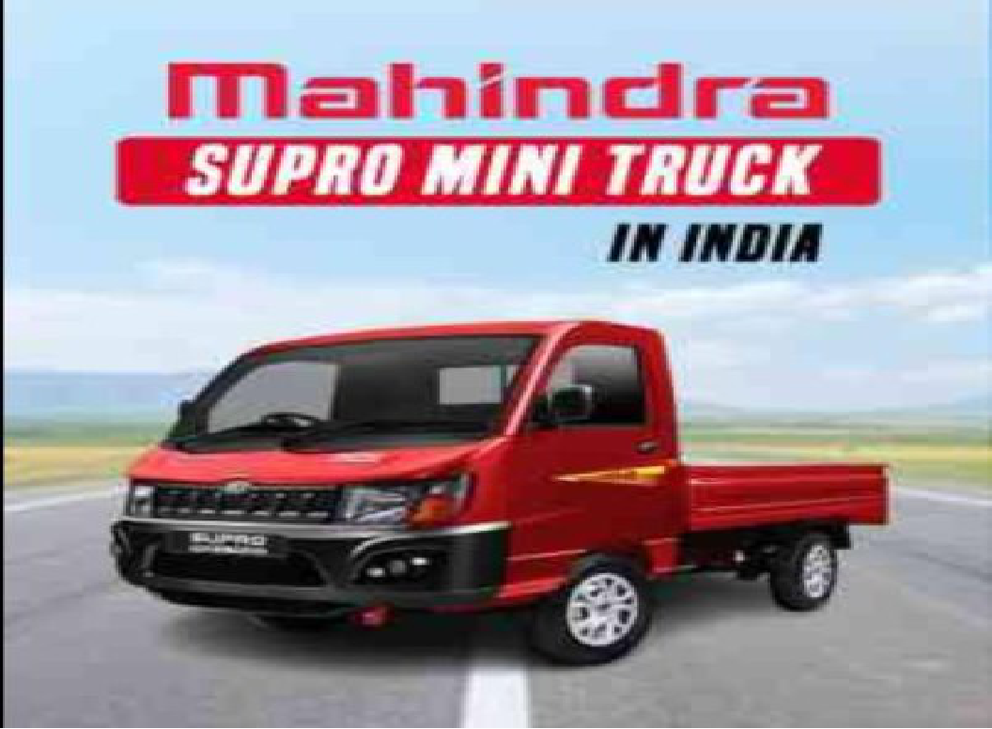

Income Level: Lower-middle to middle class

Location: Rural and semi-urban areas Interests: Business expansion, cost savings

 

 

Pain Points: Needs a cost-effective, fuelefficient, and durable vehicle for daily business

use

Buying Motivation: Low maintenance cost, high mileage, strong resale value

Preferred Vehicles: Mahindra Bolero Pik-Up, Supro, Jeeto



3. Tractor & Farm Equipment Buyers

Persona Name: Ramesh, the Progressive Farmer

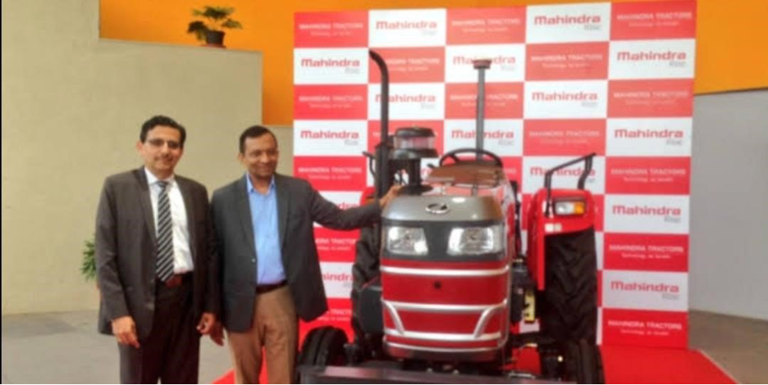

Age: 35-60

 

 

Occupation: Farmer or agricultural entrepreneur

Income Level: Lower-middle to middle class

Location: Rural areas

Interests: Farming, productivity improvement, government subsidies

Pain Points: Wants reliable, fuel-efficient, and powerful tractors at an affordable price

Buying Motivation: Performance in rough conditions, after-sales service, spare parts

availability

Preferred Vehicles: Mahindra Arjun Novo, Mahindra Yuvo, Mahindra Jivo



 



 

4. Electric Vehicle (EV) Buyers

Persona Name: Priya, the Eco-Conscious Urbanite



|  |  |  |
| --- | --- | --- |
| Age: 25-40 |  |  |

Occupation: IT professional, entrepreneur, or urban commuter

Income Level: Middle to upper-middle class

 

 

Location: Metro cities and tier-1 towns

Interests: Sustainability, new technology, fuel savings

Pain Points: Limited charging stations, range anxiety

Buying Motivation: Environmental benefits, government incentives, cost savings

Preferred Vehicles: Mahindra XUV400 EV, eVerito



5. Corporate & Fleet Buyers

Persona Name: Vikram, the Logistics Manager

Age: 30-55

Occupation: Fleet manager, corporate executive, or logistics operator

Income Level: Business or company budgetdriven

Location: Pan India

Interests: Cost optimization, operational efficiency

 

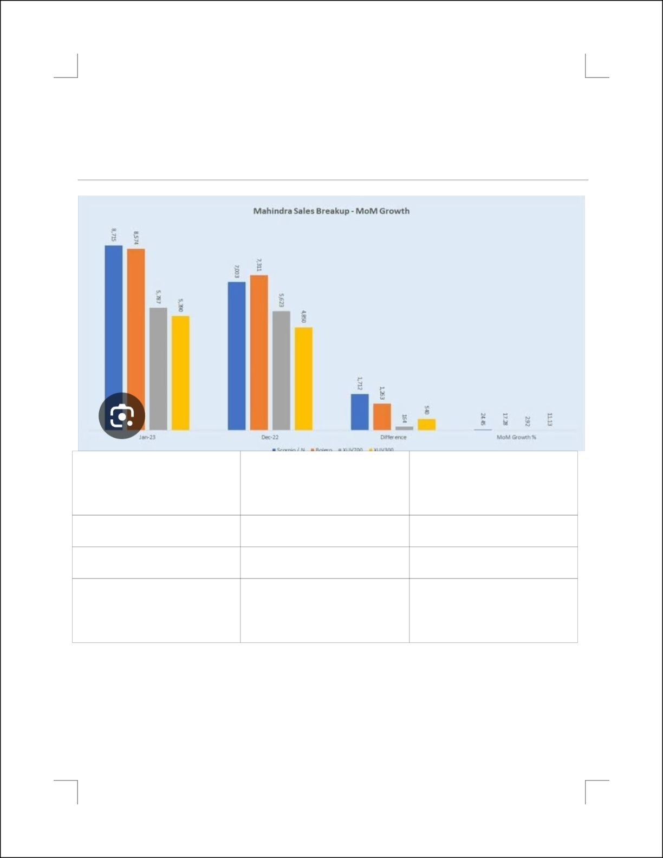

Pain Points: Need reliable, fuel-efficient vehicles with lower operational costs

Buying Motivation: Bulk discounts, service contracts, fuel efficiency   
Preferred Vehicles: Mahindra Treo (electric rickshaw), Bolero Pik-Up, Mahindra eSupro

|  |  |  |
| --- | --- | --- |
| BRAND | FOCUS | POPULAR MODEL |

|  |  |  |
| --- | --- | --- |
| Mahindra | SUVs,EVs | Thar,XUV100 |

|  |  |  |
| --- | --- | --- |
| Tata | SUVs,EVs,pas | Nexon,safari |

|  |  |  |
| --- | --- | --- |
| Maruti | Small and mid size cars | Swift,Baleno |

SEO& KEYWORD

 

REASEARCH

SEO & Keyword Research for Mahindra Company

Mahindra & Mahindra is a multinational corporation headquartered in India, known for

its automotive, farm equipment, and technology businesses. Conducting SEO and

keyword research for Mahindra involves analyzing search trends, competition, and

opportunities related to the company and its products.



1.Keyword Research for Mahindra

Here are some high-volume keywords related to Mahindra:

a. Brand-Related Keywords

 

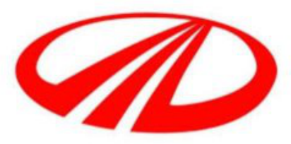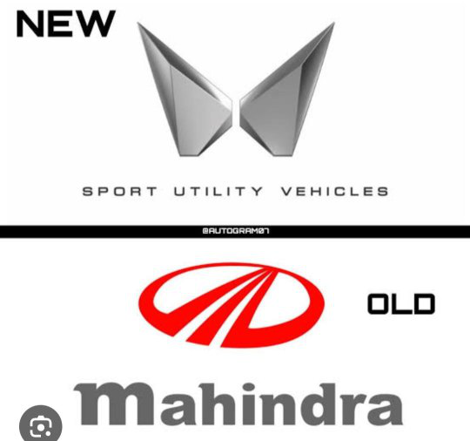

 

Mahindra & Mahindra Mahindra company

b. Automotive-Related Keywords

 

 

Mahindra SUVs

Mahindra Scorpio

Mahindra Thar

Mahindra XUV300

c.Farm Equipment Keywords

Mahindra tractors

Mahindra tractor price

Mahindra farm equipment

 



 

Mahindra Arjun tractor

d. Electric Vehicles (EV) Keywords Mahindra electric car

 

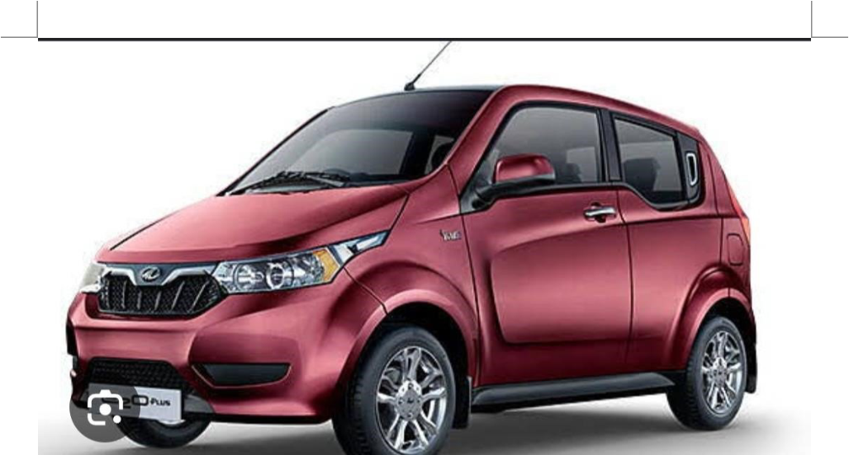

Mahindra XUV400 EV

Mahindra electric SUV

Mahindra EV price

e. Business & Stock Market Keywords

Mahindra & Mahindra share price

Mahindra company net worth

Mahindra company stock

 

 

f.Industry-Specific Keywords

Mahindra defence

Mahindra aerospace

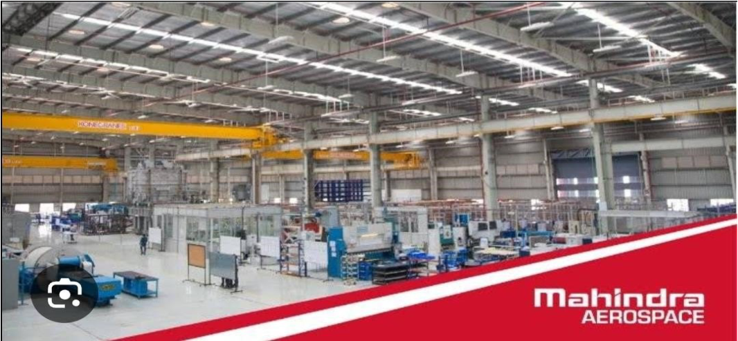

Mahindra logistics



2.SEO Strategy for Mahindra

 

 

a. On-Page SEO

Optimize meta titles, descriptions, and headers with relevant keywords.

Improve internal linking across Mahindra’s website for better navigation.

Use structured data (schema markup) to improve search visibility.

b. Content Marketing

Publish blog posts on car reviews, maintenance tips, and tractor comparisons.

Create YouTube videos showcasing Mahindra vehicles and farm equipment.

Optimize press releases and news articles with trending keywords.

c.Local SEO

Optimize Google My Business listings for Mahindra showrooms and dealerships.

Focus on location-based keywords like “Mahindra showroom near me” or “Mahindra

service center [city]”.

d. Link-Building Strategy

Get backlinks from automobile and farming websites.

 

 

CONTENT IDEAS AND

MARKETING STRATEGIES;

Mahindra operates in diverse industries, including automobiles, farm equipment, electric

vehicles, defense, and sustainability. A strong content and marketing strategy can

enhance brand awareness, engagement, and lead generation.



1.Content ideas of mahindra

a. Automotive Industry Content

Car & SUV Reviews: Detailed articles and videos on Mahindra models like Thar, XUV700,

and Scorpio.

Comparison Blogs: “Mahindra XUV700 vs

Tata Safari – Which One Should You Buy?” User Testimonials & Stories: Customer

experiences on long drives, off-roading, or safety.

Upcoming Models & Features: Sneak peeks of upcoming Mahindra cars and SUVs.

Car Maintenance Tips: “How to Maintain Your

 

 

Mahindra Thar for Long-Lasting Performance.”

Mahindra Electric Vehicles: Benefits of EVs, charging infrastructure, and range

comparisons.

b. Farm Equipment & Agriculture Content

Tractor Buying Guides: “Which Mahindra Tractor is Best for Your Farm Size?”

Farmer Success Stories: Interviews with real farmers using Mahindra tractors.

Agricultural Tips: “Best Practices for Efficient Farming with Mahindra Tractors.”

Video Demonstrations: How Mahindra tractors improve productivity on farms.

c.Sustainability & Innovation

EV & Green Tech Content: “How Mahindra is Pioneering Electric Mobility in India.”

Corporate Social Responsibility (CSR): Mahindra’s role in education, rural development,

and sustainability.

Smart Manufacturing & AI: “How Mahindra Uses AI & Robotics in Car Manufacturing.”

d. Financial & Business Content

 

 

Stock Market Insights: Updates on Mahindra’s financial performance and investment

tips.

Business Expansion News: New ventures, acquisitions, and global partnerships.

Mahindra Leadership Stories: Interviews with top executives on vision and strategy.



2.Marketing Strategies For Mahindra

e. Digital Marketing Strategy

SEO-Optimized Blog Content: Use highranking keywords for Mahindra’s cars, tractors,

and EVs.

YouTube Video Content: Car reviews, feature highlights, and virtual test drives.

Social media & Engagement:

Instagram & Facebook: Car photos, launch events, and influencer collaborations.

LinkedIn: Business updates, CSR activities, and industry insights.

Twitter: Customer interaction, product updates, and brand news.

 

 

f.Influencer & Community Marketing

Automobile YouTubers & Bloggers: Collaborate with auto reviewers for in-depth product reviews.

Farmer Networks & Agri-Influencers: Promote Mahindra tractors through real user experiences.

Car Enthusiast Communities: Engage in forums and social media groups.

g. Localized Marketing & Dealer Support

Regional Language Content: Create blogs and videos in Hindi, Marathi, Tamil, and Telugu.

h. Experiential Marketing

Test Drive Events & Off-Roading Experiences: Organize events for potential customers.

CONTENT CREATION AND

 

 

CURATION:

Content Creation & Curation for Mahindra Company

Mahindra is a diverse brand covering automobiles, farm equipment, electric vehicles,

defense, sustainability, and finance.



1. Content Creation for Mahindra

a. Blog & Article Ideas

Automobile Content:

“Mahindra XUV700 vs. Tata Safari: Which SUV Should You Buy?”

“Top 5 Features That Make Mahindra Thar the Best Off-Roading SUV”

“The Future of Electric Cars: What to Expect from Mahindra EVs”

Farm & Agriculture Content:

“How Mahindra Tractors are Revolutionizing Indian Farming”

“Best Mahindra Tractors for Small & Large Farms: A Buyer’s Guide”

 

 

“Farmers Share Their Success Stories with Mahindra Tractors”

Sustainability & Innovation Content:

“Mahindra’s Green Initiatives: Leading the EV

Revolution in India”

“How Mahindra is Using AI & Automation in Car Manufacturing”

“Mahindra’s Impact on Sustainable Farming Practices”

Business & Financial Content:

“Mahindra & Mahindra Stock Analysis: Is It a Good Investment?”

“The Growth Story of Mahindra: From Automobiles to Global Expansion” “How

Mahindra is Transforming India’s Defense & Aerospace Sector”

b. Video Content Ideas

Product Walkthroughs:

“Mahindra Thar: A Deep Dive into Its Features & Performance”

 

 

“Mahindra XUV400 EV: First Look & Review”

“How Mahindra Tractors Help Farmers

Improve Productivity”

Behind-the-Scenes (BTS) Content:

“Inside Mahindra’s Car Manufacturing Process”

“How Mahindra Designs the Safest SUVs for Indian Roads”

User Stories & Testimonials:

“A Mahindra Thar Owner’s Off-Roading Adventure”

“How a Mahindra Tractor Transformed a Farmer’s Life”

Live Events & Webinars:

“Mahindra’s Future Plans: CEO Live Q&A Session”

“The Rise of Electric Vehicles in India: Expert Discussion”

 

 

c. Social Media Content

Instagram & Facebook:

High-quality images & reels showcasing Mahindra cars and tractors.

User-generated content (customer photos & reviews).

Polls & Q&A sessions about Mahindra’s latest models.

 



 

NAME:N.HARIKA

COLLEGE: VASAVI MAHILA KALASALA

 

 





 

 



 

 



 

 

 

 

 

 

.

 